FGCU Service Learning Opportunities
- Coastal Cleanup- September 18th (8-1)
- FGCU MADD- October 23rd (9-1)
- Englewood Beach WaterFest- November 20th-21st (9-4)
- Garden of Eatin’ Food Pantry- Thursdays every week (9-4)
- Garden of Eatin’ Garden Days- The second Saturday of every month (9-12)

Education
We are looking for an intern for the fall of 2021 and spring of 2022 who would like to learn more about the Keep America Beautiful Behavior Change program, Waste-In-Place, and go into elementary classrooms to do the activities with the students. Teaching them about the care and keeping of our earth. We also present two mornings per month at the Garden of Eatin’ to homeschool students! This is a minimum of 10-30 hours per week and you must be available during the day. Child and Youth Studies, Education or Environmental Education majors preferred, but all are welcome to apply!

Want to create your own service learning opportunity?
- Like shooting videos? We would LOVE videos educating folks on how they can help their environment.
- Love books and want to get in touch with your inner librarian? We have tons of books to organize and find homes for.
- Are you a social media guru or want to learn more? KCB could use frames and posts for different days of the week!
- We can work with your talents or major and come up with a project for you!

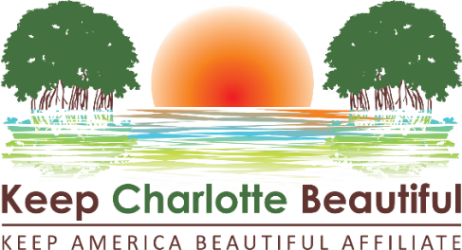
Call Rhonda Harvey at 941-764-4390 or email Rhonda.Harvey@charlottecountyfl.gov

